

**Inflation and growth in the service industries**

Speech given by DeAnne Julius

23 March 1999

I am grateful to Nick Oulton, Services Project Director, and others at the Bank of England for their assistance and inputs to this paper. The views expressed are my own.

Thank you, Mr Chairman….

May I say, first of all, how pleased I was to receive the invitation from John Arnold to present one of your prestigious Vital Topics lectures here in Manchester. I have long followed the work of the Business School and, as a former businessperson myself, I have benefited over the years from its insights and ideas. I hope tonight I may be able to contribute, at least in some small way, to its future research agenda on what I consider to be an under-explored, but very large, region of our economy: namely, the service industries.

Before I get into the substance of that topic, I thought perhaps I should say something about the monetary policy backdrop that has caused me to take a particular interest in services. I don’t need to say too much to this audience because many of you will have attended the Vital Topics lecture given here last year by Eddie George, the Governor of the Bank of England. Naturally, as I began to prepare this speech, I had a look at what the Governor said to you then. As you have undoubtedly read in the papers, we are an independent lot on the Monetary Policy Committee, and we don’t always agree with each other, at least when it comes to the vote on interest rates. In this case, however, I can fully support the Governor’s view that giving operational independence to the Bank of England to set interest rates in order to achieve the Government’s inflation target provides a sound basis for delivering the low and stable inflation that is a pre-requisite for sustained economic growth.

He sketched out the new framework for monetary policy whereby there is a clear division of labour between the Bank and the Government. The Chancellor specifies the inflation target at budget time. For this year, just two weeks ago, the Chancellor confirmed that our target would remain at 2.5% inflation per year as measured by the Retail Price Index excluding mortgage interest payments, or RPIX. This is the target we have had since the Monetary Policy Committee was set up in May of 1997. With the target set annually by Government, we then meet monthly to discuss our analyses since the previous meeting, to review the most recent evidence on the state of the economy, to compare what has happened with our projections for the future path of growth and inflation and, finally, to debate the arguments for and against a change in interest rates. The minutes of those meetings are published on the Bank’s website two weeks later along with the votes of all 9 members of the MPC.

That is the basic process that the Governor outlined in his speech here last February. I am pleased to be able to report to you, 13 months later, that it is working very well. Inflation has been at, or within a whisker of, 2½% for 8 months now. Because of the interest rate increases during 1997, the economy was slowed before inflationary pressures became intense; and rates peaked at 7.5% in June of last year. During the previous economic cycle, as I’m sure many of you well remember, they went up to 15% and stayed there for over a year.

Because inflation was held in check by the interest rate rises during 1997, this country was in a good position to respond to the global economic slowdown that began later that year with the exchange rate crises in

Thailand and Korea. The MPC’s objective is to keep inflation in the UK as close as possible to 2½% - no more, but also no less. That has meant that we have been cutting rates since last October to support demand at home as exports and international prices were weakening. We cut rates five times in five months, by a total of two percentage points to their current level of 5½%. This has brought mortgage interest rates down to their lowest level in 30 years, as many of you will be aware. It has helped to turn around the fall in business and consumer confidence that we saw last fall, and it has laid the groundwork for the recovery in growth that we expect to see during the second half of this year. Our forecast for inflation is that it will remain on track at 2½%.

Having said all this, there are probably some in this audience, perhaps especially from the manufacturing sector, who are finding the business environment they face considerably more threatening. Output in manufacturing has fallen for 5 of the last 6 months and prices at the factory gate – far from growing at 2½% – have been flat. With labour costs having risen 3.6% over that period it is no wonder that employment in manufacturing has been dropping and profitability is low.

The difficulties faced by manufacturers and other internationally exposed sectors are of concern to all of us. But a key constraint of monetary policy – and therefore of the Monetary Policy Committee – is that we have only one tool, the interest rate, to use in trying to achieve a single inflation target for the country. We do not have the ability to fine-tune or differentiate our policy. It is not like fiscal policy, where a myriad of tax rates and targeted incentives or exemptions are available for the chancellor of the day to consider. We all know that at any point in time, some regions of the country and some sectors of the economy will be growing faster than others. Our task on the MPC is to give due consideration to each of them, and then to set interest rates to achieve our inflation target across all of them.

This is easier said than done. For various historical reasons, there is much more statistical detail and established survey information on the manufacturing sector than on services. This would not matter greatly if manufacturing accounted for the bulk of the economy or if the inflation performance of the two sectors were broadly similar. Unfortunately for us, neither of these two propositions is true. Manufacturing accounts for just 22% of UK output while the service sector (excluding government) accounts for 45%. The inflation rate of goods over the past year has averaged 1.4% while that of services has averaged 3.4%. Furthermore, these two differences are neither recent nor random phenomena. They represent longterm trends that are also evident in other European and North American economies. That is why a clear understanding of how the service sector behaves, in terms of growth and inflation, is necessary for us to set interest rates for the economy as a whole.

# Growth

I will start with the growth performance of the service sector and then move on to inflation. First, an important qualification: the distinction between goods and services that I shall be using in the figures that follow is an

imprecise one. It follows conventional statistical practices, but it obscures both the diversity within the service sector and the close linkages between the goods producing and the service-providing parts of our economy. Each produces things consumed by the other. Part of the growth in jobs classified as services reflects the outsourcing of activities previously carried out in manufacturing firms. When an engineering plant turns over the management of its staff canteen to outside caterers, then according to the statisticians, jobs have been ‘lost’ in manufacturing and ‘gained’ in services, even if the same people are doing the cooking.

But we must make the best of the numbers we have. And in order to make useful comparisons about the economy as a whole, we have to use aggregated figures. The categories I will be using are shown in Figure

1. I divide the economy into three sectors: Goods, Market Services and Government Services. The goods sector is mainly manufacturing, but it also includes construction, mining, energy and agriculture. Government Services includes all the things paid for by taxation, rather than by the individual users of each service. These include the health service, education, police, defence, social services, and so on. A large share of employment is in these sectors, but one would not expect their economic behaviour to be the same as that in the private sector, where market disciplines apply. The third sector, which I call Market Services, is really the focus for tonight. These are the services provided (almost entirely) by private sector firms. This category covers a huge spectrum and therefore we will find it illuminating to sub-divide it into its three main components. The first is Transport & Communications which covers planes, trains, buses, mobile phones and telecommunications of all sorts. Companies providing these services are mostly large, capital-intensive firms, some of which used to be in the public sector. Trade, Tourism & Leisure includes wholesale trade and retail shops, hotels and restaurants, theatres and sports, and personal services such as hairdressers and aerobics trainers. Many of the companies in this part of the service sector are small firms and most of the services they sell are to final consumers rather than other firms. Financial & Business Services covers banking, insurance, real estate, advertising, legal services, accountancy, contract cleaning, etc. Firms in this sector may be big or small, employees range from the most highly skilled to the unskilled. They share the characteristic that most of their customers are other firms, rather than households.

Figure 2 shows how output in the UK economy stacks up across these three sectors. About 45% of UK production is Market Services. Another 18% is Government Services. The final one-third of the economy consists of the production of Goods. This chart shows why the MPC must look beyond what is happening in the manufacturing sector. Manufacturing is shown within the Goods column, and by itself accounts for just 22% of total UK GDP. Almost the same percentage is contributed by Trade, Tourism & Leisure. Another 18% comes from Financial & Business Services. The Market Services sector as a whole is one third larger than Goods.

Furthermore, the share of Market Services (in constant prices) has been rising steadily over the past 20 years, apart from during the 1991 recession. By 1997 it was 10 percentage points higher than in 1979. The UK is not alone in this trend. A similar rise in the share of services output has been underway in most so-

called industrial countries. The UK now has the second highest share of services in its GDP, after the United States. Italy and Germany are among those with the lowest shares.

The picture is even more striking in terms of employment. (Figure 3) Over half of the British labour force is employed in Market Services, while just 19% work in Manufacturing and 27% in the Goods sector as a whole. Here in the North West (excluding Merseyside), the employment picture closely parallels the national average. The share of employment in Market Services is 46%, compared with 28% in Goods and 26% in Government Services. As you might expect, the highest share of employment in Market Services is in the South East and London – where it tops

65% - but even excluding those two areas completely, there are nearly double the number of people working in Market Services as there are in Goods in the rest of the country. Under these circumstances it would be risky indeed to steer monetary policy on the basis of surveys and statistics about employment or employment intentions in the manufacturing sector.

This shift of the overall economy towards Market Services is well illustrated by developments here in the North West. This is a region with strong historical roots in manufacturing and industrial innovation. The first stored programme computer was built here in Manchester and that became the basis of IBM’s first digital computers in the 1950s. That high-tech tradition is in evidence not far from where we sit tonight in the Manchester Science Park. While these high value-added elements of manufacturing – such as design and the commercialisation of technology – will remain important to the region’s future, the routine production and assembly tasks will inevitably continue their migration to lower cost countries. Net job creation has been and will continue to be in services. Already the North West is the largest centre for banking, management consulting and advertising outside London. It is the leading centre of the UK mail order industry with 3 of the top 6 companies headquartered here. The Trade, Tourism & Leisure sector employs over one-quarter of the workforce and brought more than £3 billion into the regional economy last year. The redevelopment of Salford Quays into The Lowry, with its art galleries, performance spaces and virtual reality research, provides a graphic illustration of the economic transformation of this region. The North West, like the UK as a whole, is already a service-dominated economy.

Some commentators think this is a problem. They worry that investment will slow in a service-dominated economy, leading to lower productivity and growth. They fear that new service jobs mostly require low skills and are therefore low paid, compared to the manufacturing jobs that they are replacing. Neither of these worries is supported by the evidence so far. More than half – 52% – of total UK investment is undertaken by firms in Market Services, compared to 34% by Goods sector firms. The Services share has been growing, and so has the growth rate of labour productivity in the economy as a whole. During the previous economic cycle, between 1979 and 1990, labour productivity grew at an average annual rate of 2.2%. It has accelerated during the 1990s to 2.5% as shown in Figure 4. Productivity statistics are notoriously imprecise and volatile year to year, so I would not place a great deal of faith in the precise numbers. But during the

period 1990-96 the sub-sectors showing the greatest growth in labour productivity were Transport & Communication and Manufacturing. Productivity in Trade, Tourism & Leisure grew by 2.6% per year which is slightly above the economy-wide average. Slower productivity gains were recorded in Financial & Business Services, while Government Services was the laggard, showing virtually no productivity growth over this period. However, I stress that it is particularly difficult to measure productivity in Financial & Business Services so these figures may understate their true performance. And, until recently, productivity growth in Government Services was based more on assumption than on measurement.

There is another wrinkle in relating productivity in the sub-sectors to that in the economy as a whole. The growth rate of labour productivity in the economy as a whole is determined by productivity growth in the individual sectors and also by shifts in the allocation of resources between sectors. If some sectors within Market Services have low productivity growth, as the official measures suggest, then shifts of resources towards these sectors will tend arithmetically to reduce the overall economy growth rate. But the level of productivity matters too. And here it is pertinent to note that productivity levels, measured by value added per person employed, differ substantially between sectors. In 1997 the level of labour productivity in Financial & Business Services was 20% higher than that in the Goods Sector. So shifts of jobs from Goods to Financial & Business Services may raise, rather than lower, economy-wide productivity despite slower productivity growth in Financial & Business Services.

This brings me to the second worry that some people have about the shift to a service-dominated economy. Are we trading in high paying manufacturing jobs for low paid service jobs? If automotive assembly moves off-shore, are we doomed to become a nation of hamburger-flippers? Of course, we all know that there are both high skill and low skill jobs in both manufacturing and services. But is there any truth to this worry at an aggregate level? Figure 5 shows how average earnings for full-time workers in the various sub-sectors currently compare. The highest paid are in Financial & Business Services, at an average of more than £10 per hour. Next comes Government Services, then Goods. Jobs in these three sectors pay above the national average and most of the people who work in these sectors provide services rather than produce goods.

However, the two sectors that pay below average wages are also service sectors: Transport & Communications and Trade, Tourism & Leisure. So we are left with the common sense conclusion that there are both highly paid and low paid jobs in the service sector: it is the level of skill, not the classification of the job, that determines pay. And this economy has been creating jobs in both the highest and the lowest paying parts of the service sector.

In particular, over the past year employment has grown and unemployment has fallen in the UK to its lowest level in nearly 20 years despite the loss of 129,000 jobs in manufacturing. And inflation has remained on target as overall unemployment has dropped to these historic lows. The story is similar in the United States. There too job growth in services has more than offset job losses in manufacturing, the nation-wide unemployment rate keeps hitting new lows, and inflation remains below 2%. Perhaps it is more than a coincidence that these are also the two countries with the lowest shares of total employment in

manufacturing. In the US just 14% of the labour force works in manufacturing; in Britain it is 19%; while in Germany it is still 27%. A cross-country comparison (Figure 6) shows a steady decline in unemployment rates in the US and UK, compared with a rise in France and Germany over the past 6 years. There are many reasons behind this – some cyclical, some structural -- but one of the key factors may be the ability of a large and competitive service sector to create jobs of all sorts – full-time, part-time, high-skill, low-skill – in response to changes in the demand and supply conditions in both product and labour markets. Such flexibility in a very large part of the economy may enable it to reach a higher level of employment without igniting inflationary pressures.

If this is true, it would clearly be of great importance for monetary policy. It would mean that we could achieve the same inflation target at a higher level of economic growth, at least for a while. And over the economic cycle, changes in interest rates might provoke less violent swings in unemployment than in the past as people moved from full to part-time work or into and out of the labour force. Much evidence will need to be accumulated before one can be convinced of such changes. But it is not too soon to start looking for them.

One place to look is for structural differences between jobs in services and jobs in goods. Two striking differences emerge. First, there are many more part-time jobs in services. Only 7% of Goods jobs are part- time, compared to 35% of jobs in Market Services and 38% in Government Services. The differences are even greater when one looks at the biggest job creators within Services. Figure 7 shows the full-time/ part- time split of jobs in each of our major sub-sectors. Goods and Transport & Communications are at one extreme with just 7 and 11% of their jobs for part-timers. Both of these sectors have seen employment shrinking by over 2% per year since 1990. At the other extreme are Government Services – where employment has been stagnant – and Trade, Tourism & Leisure, where 43% of jobs are for part-timers and employment creation has been very strong since 1990. The other big job creator has been Financial & Business Services where part-time workers account for a substantial 30% of the total. We know from the Labour Force Survey that the vast majority of people working part-time do not want a full-time job. There is a clear implication here – though not conclusive proof – that the expanding sectors of the economy are also those which have more flexible working patterns, and that those patterns attract people into their workforce.

The second striking difference between jobs in the Goods and Services sectors is the gender of their occupants. Put more simply, if less politically correct, the majority of people working in Goods are men, while the majority working in Services are women. Again, the difference across the sub-sectors is surprisingly great. (Figure 8) While the workforce as a whole is split almost exactly 50/50 between men and women, fully 70% of those working in Goods sectors are men while 70% of those working in Government Services are women. And the two sectors that have shed jobs during the 1990s are those most heavily occupied by men – Goods and Transport & Communications – while the big job creators are those where women make up the larger share of the workforce – Trade, Tourism & Leisure and Financial & Business Services. Survey evidence again suggests that these patterns reflect the preferences of the employees rather than discrimination on the part of the employers.

In sum, women make up more than half the employees in Market Services. And over half of them are part- time. By contrast, men constitute three quarters of the employees in Goods and nearly all of them are full- time. Market Services have been creating jobs while Goods have been shedding them. The relevance of this to growth and inflation is that women tend to move into and out of the labour force more often than men during the course of their working lives. They spend more time in the category of ‘economic inactivity’ which is surely a misnomer for the state of being a housewife or a student! When the labour market is tight they can be tempted to take a job, especially if a part-time one is on offer. This flexibility has meant that employment could expand – because much of it was in sectors willing to offer part-time work – without running into the labour market bottlenecks that during previous upswings have put strong upward pressures on wages, and eventually prices. It is possible that this shift in the composition of the labour force and the split between full- time and part-time employment has reduced the so-called natural rate of unemployment – the rate below which inflation starts to accelerate. If so, that is good news indeed for economic growth and for the opportunities available for women. It may also have fundamental social effects on family life and the economic role of men – but that is a Vital Topic for another day.

Let me now turn to my final subject: the behaviour of inflation in the service sector. The Chancellor has set the MPC a single target for inflation, 2.5% per annum as measured by the RPIX. The rate at which the RPIX rises is a weighted average of the rates at which the components of the index – such as goods and services

-- are rising. There is no target for any of the individual components. So in theory each component can rise or fall at any rate whatever, provided the average, the RPIX, rises at the target rate. Just as the MPC can only seek to set monetary policy in accordance with the needs of the economy as a whole, not those of any one region or industry, so it seeks to keep the average rate of inflation at the target rate, not the prices of any particular component of the RPIX.

In practice, the inflation rates of the goods and services components of the RPIX have shown a tendency to behave rather differently. It is useful to monitor them separately in order to understand better what is happening to inflation in the economy as a whole. One of the most striking regularities is that the prices of services tend to rise more rapidly than the prices of goods. Figure 9 shows how the goods and services components of the RPIX have moved since the beginning of the decade. Over the 9 years to this January, prices in the whole of the economy have increased by a bit less than 40%. But the prices of goods have risen by about 32% while those of services have increased by 53%. The UK is not alone in finding that services prices usually rise faster than goods prices. The same is true in the US, Germany, France and Japan.

In the UK the differential between inflation in the two sectors – that is, inflation in services minus inflation in goods – has averaged 1.7% over the past 15 years. There has been considerable variation over this period. During the depths of the early 1990s recession when goods prices were particularly hard hit by the strength of sterling, the differential rose to a peak of 4.9%. Then it fell back and actually turned negative for a period in the mid-1990s when the prices of the regulated utilities showed a strong decline. But since its trough in

December 1995, the differential between services and goods inflation has been rising again and in recent months it has been around 2%.

Services currently make up 39% of the consumption basket of households whose purchases are represented in the RPIX, while goods make up the other 61%. So if the differential between services and goods inflation is generally around 1.7%, and the Government’s inflation target is 2.5%, then that target will be met with services prices generally rising at 3.5% and goods prices rising at 1.8%. We will come to the reasons behind this differential in a moment. But it is important first to recognise its existence, in other countries as well as this one, and its persistence over time, albeit sometimes exacerbated or masked by movements in the exchange rate or changes in government taxes or regulations. It would not be appropriate to conclude, as some commentators have, that with goods prices rising at only 1.8% the inflation target will eventually be undershot. Nor is it appropriate to worry that because service prices are rising by 3.5% the inflationary pressure in the economy is too high for the continued achievement of the overall inflation target without a rise in interest rates. Since inflation in services is sometimes used as a proxy for the economists’ unobservable concept of ‘domestically generated inflation’, this persistent differential is an important qualification to keep in mind. A rate of services inflation of 3.5% will generally be consistent with achieving an inflation target of 2.5%.

The overall rate of inflation is a monetary phenomenon but the inflation differential between services and goods is a real phenomenon: it is the rate at which the relative price of goods and services is changing. It is determined by real forces at work in the international economy and is largely independent of monetary policy. To illustrate, the differential between services and goods inflation is about the same now – at two percent -- as it was in January 1988. But RPIX inflation then was 4.6% while in January 1999 it was 2.6%.

So what are the real forces which determine the differential? We may get a clue by seeing if it is specific to particular service prices or if it is more widespread. Figure 10 shows the total percentage increase since 1987 in the prices of the 22 service components of the RPIX compared to goods. Nearly all of the services prices rose faster than goods. In fact, the only services whose prices rose more slowly than goods were regulated by government; i.e., telephone charges, gas, TV licenses and electricity. (Parenthetically, not all regulated services showed such price restraint. Water charges rose faster than any other component of the RPIX over this period.) But the striking fact remains that where prices are determined in competitive markets, services prices show a widespread tendency to rise relative to goods prices.

Research is underway at the Bank and elsewhere to explain what lies behind this. The two factors that appear to be the most important in explaining the differential are, first, the degree of labour intensity of the industry and, second, its rate of productivity growth.

Take labour intensity first. Firms that employ relatively more labour than capital, compared to other firms, will find that their total costs are relatively more dependent on the wage costs of their employees. We have

already seen that wages differ widely across industries and occupations. But there is a broad tendency for average wages to rise over time at the rate of inflation plus the average rate of productivity growth in the economy as a whole. Meanwhile, at least over the past decade, the cost of many capital goods has actually fallen, especially those incorporating computer technology. Thus firms that are more labour intensive, where wages are a higher proportion of total costs, have seen their costs rise faster and have been able to pass on some of this in higher prices.

Next, consider productivity growth. Opportunities for raising efficiency differ between industries. In some, new technology brings a flood of new ideas, new techniques and, often, labour-saving new machines. In others, much less change is apparent. Rapid productivity growth leads initially to high profits. Then, either the existing firms expand, or new firms enter the market, in the process driving prices down. In other words, higher than average productivity growth tends to be accompanied by lower than average growth of prices.

This has been a worldwide story, first for agriculture since the 1950s and then for much of manufacturing during the 1980s and 1990s.

It has often been argued that service industries are labour intensive and have inherently low productivity growth. So they have two strikes against them and at first blush we seem to have a ready-made explanation for the services/goods inflation differential. But matters are not quite so simple and that is why further research is needed.

The correspondence between service products in the RPIX and service industries is not very close. So even if it were true that services are more labour intensive and have lower productivity growth, this would not necessarily explain the differential in prices. In addition, the prices of goods in the RPIX include the prices of many services; for example, the wholesale and retail margins and the transport cost of getting the goods from the port or factory to the consumer. Financial & Business Services are a major service industry but they play a very minor role in the RPIX. This is because most of their output is sold to other firms, not directly to households. But this means that the price of everything that consumers buy, whether goods or other services, is influenced to some extent by the prices charged for Financial & Business Services. And that, of course, depends partly on productivity growth in that sector.

The problem becomes complex, but this brings us full circle to the qualification I made at the outset of this lecture: that although I am focusing tonight on the key differences between goods and services, it is also important to understand their inter-relationship in the economy as a whole. Further research, using input- output data, is underway in this area.

Let me conclude with a few words about what the future may hold for this service-dominated economy.

The shift of employment towards the service industries is a long-term trend in all advanced countries. There is no reason to think that it is about to halt, still less reverse, in the near future. The sectoral pattern of

employment in the UK is approaching that in the United States, which is presumably further down the road on which we are travelling. Goods still account for 27% of employment in the UK, compared with 21% in the US.

Given the large and still rising importance of services, the future prosperity of the British economy will be largely determined by the competitive success of its service sector. There are two ways in which the higher living standards and better public services which most people want can be achieved. The first is through rising productivity. Here the record of services is rather mixed. In Transport & Communications productivity growth has been strong, but that may partly reflect the large one-off gains many companies in this sector made after privatisation. Productivity growth in other Market Services has tended to be below average, at least if we rely on official measurements. However, there are some well-known difficulties in measuring output in services and the problems are particularly acute in Financial & Business Services. So it is possible that productivity growth may be faster than statistical estimates currently show. Certainly the skill base in this sector is strong, wages are high, exports have been growing and profitability has been above the economy- wide average. These are all signs of a highly competitive industry.

The second route to higher living standards is through expanding employment opportunities. Unlike rising productivity, which in principle can go on forever, there is an upper limit to the size of the labour force. But one of the surprises of the long-running US expansion has been the continuing rise in the participation rate of women and older people in the job market. In the short to medium term getting more of the population into

work has important economic as well as social benefits. That requires upgrading the skills of those who find it difficult to hold a job. And it requires more flexibility in job specification so that different working hours and working patterns are on offer to suit the diverse preferences of different workers.

Service sector jobs seem to fit this bill. The UK has built an enviable record of job creation in private sector services over the last decade. No one welcomes the jobs lost in manufacturing, but we should not let this blind us to the impressive gains made in services. Worries that a service-dominated economy will suffer from low productivity or low wages are not supported by the evidence, either in this country or in the United States. There is evidence that inflation is generally higher in services than in goods, but this persistent differential, when properly understood, does not threaten the achievement of the inflation target for the economy as a whole. Indeed, it is just possible that the greater flexibility of jobs in services may be helping us to achieve low and stable inflation at lower levels of unemployment than this economy has managed for many decades.

# Figure 1

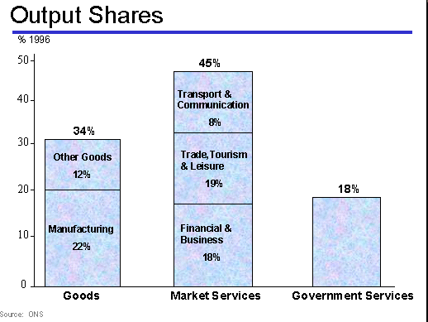**Figure 2**

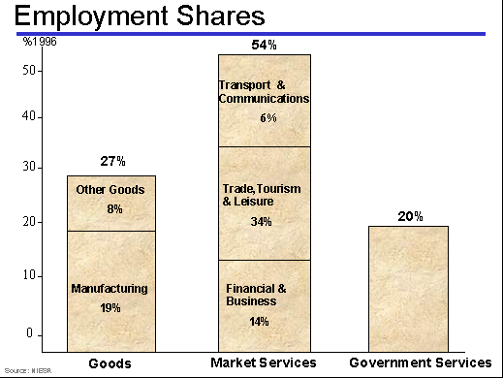**Figure 3**

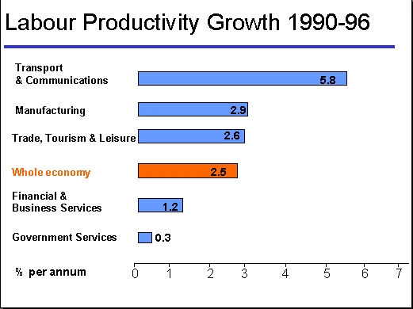**Figure 4**

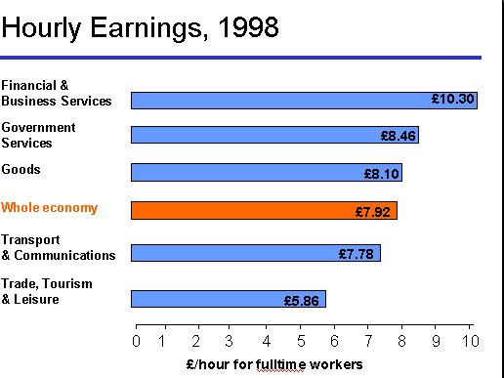**Figure 5**

**Figure 6**

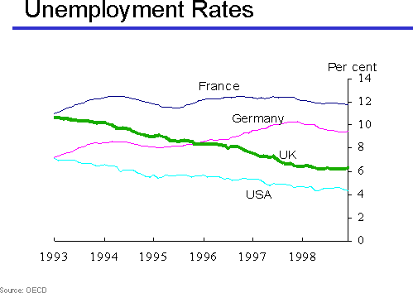

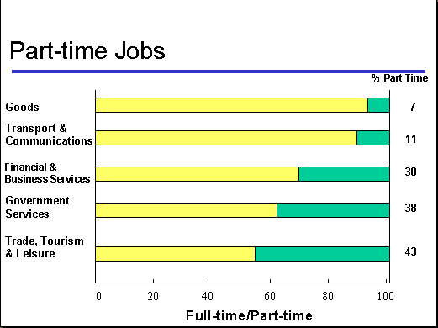**Figure 7**

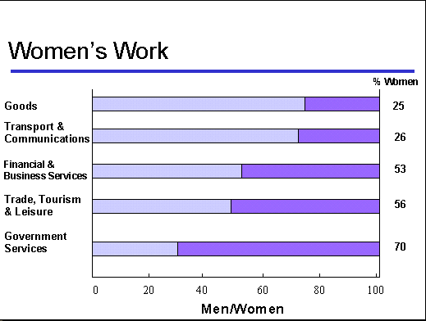**Figure 8**

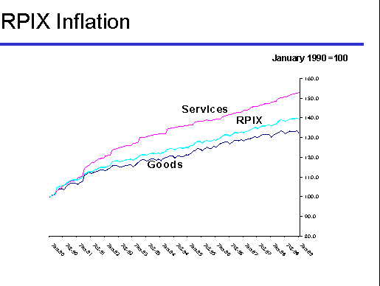**Figure 9**

**Figure 10**

